Sheldon Christian Scout
January 2023
Sheldon Christian School Prepares God’s children for a lifetime of kingdom service by providing quality God-centered education.

ADMINISTRATOR’S NOTE

In Paul’s letter to the Corinthians, he was forced to confront several problems. And (it) could have become one long, verbal spanking. Instead, Paul…practiced “The 101% Principle” -finding the 1 percent you can affirm, and giving it 100 percent of your attention. Leadership rule #1 is this: Affirmation comes before confrontation. Good leaders look for the good in people and affirm it. Only then do they address the problems. I Corinthians 1:10, “Now I plead with you, brothers, by the name of our Lord Jesus Christ, that you will all speak the same thing, and that there be no divisions among you, but that you be perfectly joined together in the same mind and in the same judgment.”
Why am I talking about “The 101% Principle” for leaders? Because I think it fits very well with our strategic roadmap for Sheldon Christian School and the “Student First Act” pertaining to Educational Savings Accounts (ESAs) in the state of Iowa. I ask that each and every one of you continues to pray for Sheldon Christian School as we strive to live out our Christian calling as school leaders and staff. We are continually asking ourselves how we need to be influencers of a very intentional God-centered education for every family that enters our school building. We want to see the good in all people and give them an opportunity to become stronger in their faith. I want to confirm that the Sheldon Christian School Board is continually leading by example with the core values of Sheldon Christian School at the center of their conversation. We will have new roads to navigate, but we promise to continually keep the mission at the very center of our conversations. This school family has built itself on trust and affirmation. We ask that you continue to keep the board, staff, parents, and students in your daily prayers. With the possible future challenges (positive and/or negative) that may arise are able to be overcome with true leadership, unity, and love. I will continue to share information as details become available on the recent passage of the Educational Savings Accounts bill

In His Service,
Marlin Schoonhoven

Eighth GRADE NEWS

The Eighth grade class will be working on their History Fair projects over the next month. They will be doing research on a particular historical event. They will be documenting specific information to use for a written report. They will be creating a display that depicts the specific event as well as visual artifacts to coincide with the display and the reported information.
The students will be presenting these projects on March 14 from 5-7pm in the evening for everyone to come and see.
The eighth grade has been doing a wonderful job at leading their own chapel groups each month. They enjoy talking with their small groups about the theme and how they can be put into action in their own life. Also, last month (December) they led the monthly chapel. The theme for the month was “Obey Your Parents” and that means more than following rules. It means showing thankfulness for all our parents do for us as well as the love they show us in all circumstances. Pastor Bryan Anderson from Tabernacle Baptist Church was the guest speaker, he emphasized the importance of honoring our father and mother and understanding their deep love for us through the following rules. It is how we grow spiritually in Christ and His unconditional love towards all.

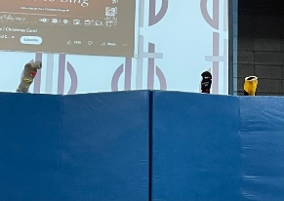
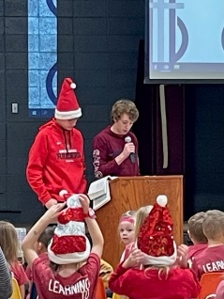

Sixth Grade Chapel
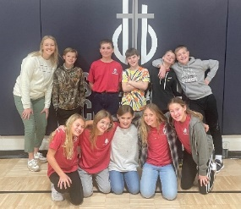
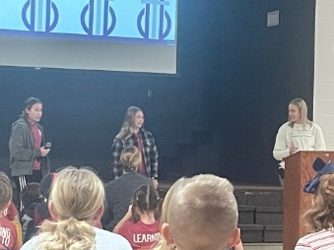
On January 18th, the 6th grade did a great job teaching us the importance of the commandment, “Do Not Kill”.
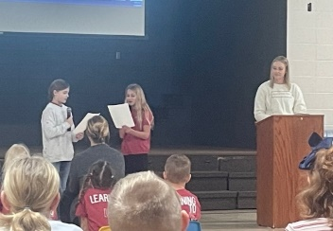

Preschool News

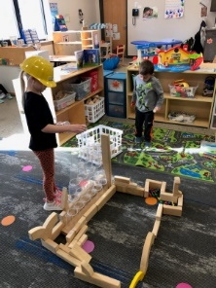
Center time is the portion of the morning where the preschoolers can have structured play time. Working together or independently preschoolers have a chance to discover God through the BIG and little things. Recently, we have added the bear cave to our center time play. Here preschoolers are welcomed to work on puzzles or play games. Our sensory table is filled with kinetic sand which students can squish, squeeze, and mold. Blocks is always a favorite of the preschoolers. Together, the preschoolers create incredible buildings!

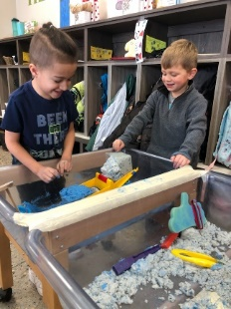
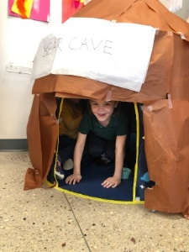
Bear Cave (Thaddeus Dunn)
Sensory Table ( Carlos Tornez, Jack Van Kekerix)
Blocks (Zoey Hengeveld, Lennox Stover)

Second Grade News

This year in 2nd grade we have been blessed to have a PDS student from Dordt University. Her name is Bianca Van Berkel. She grew up in Sioux Center and attended Unity Christian. As a PDS student, she has been a part of our classroom since our first day of school. However, the first semester she only came Monday through Thursday from 8:00-11:00. From January through early March, she is in our classroom all day, every day. This makes the 2nd grade students (and Mrs. Dykstra) extremely happy! Miss Van Berkel has been helping us learn how to add 3-digit numbers in math. In reading class we are working on our oral reading skills by learning new phonics patterns each week. We have been enjoying learning about Jesus’ ministry in Bible class. In science we have been doing many hands-on activities that have helped us better understand erosion and the properties of materials.
One of our favorite times of the week is Friday devotions. We start the day choosing praise songs and worship Jesus with our singing, actions and prayers.

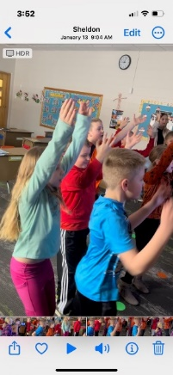
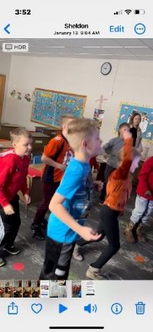
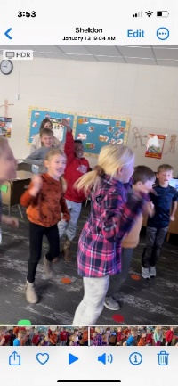

Kindergarten News

Eggstra Exploration

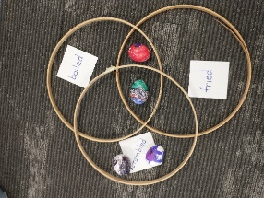
The Kindergartners each brought a hard-boiled egg to school as they studied the short sound of the letter "e." They decorated their eggs. They then placed them in a Venn diagram to indicate if they liked to eat their eggs scrambled, fried, boiled or a combination of those choices. Next, they used a scale to weigh their eggs against each other finding out whose egg weighed the most and the least. Last, they weighed their eggs against crayons and cubes graphing their results.
For science, they learned the parts of an egg. Do you know what the white part is called? (Answer below) Most of the kindergartners even braved touching the membrane! They looked for the three states of matter as Mrs. Geels cracked and fried an egg. They were especially amazed at how a little drizzle of water in the frying pan quickly turned to steam. They used their observation skills to watch what happened to an egg in water versus vinegar. What a surprise it was to see that the shell of the egg in vinegar totally disintegrated exposing the membrane. Hopefully the students had eggstra fun discovering some of God's hidden wonders in an egg.

Answer: albumen
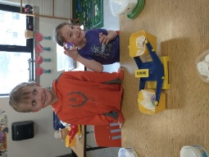
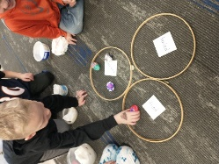
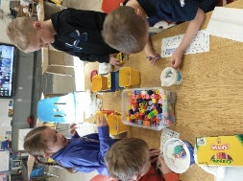

Upcoming Events:
February 6 – 13: Assessment Week
February 14 & 16: P/T Conferences
February 17: No School
March 14: Wax/History/Science Museum
8th grade graduation: May 25th @ Immanuel; 7:00 p.m.

Fifth Grade News
Did you know there was a man that survived over a year on a wrecked ship in the ocean? Did you know that only about 2% of the earth's water is freshwater? Did you know we use more than 60 gallons of water each day? 5th graders have enjoyed Mystery Science, an online science curriculum that puts science in the real world and includes hands-on projects. Students used maps and math to make a sticker bar graph to see exactly how much salt water, frozen freshwater, and freshwater was in the world. They were shocked to see 79 stickers by salt water and only 1 sticker by fresh water. Students will be learning more about the water cycle, ground water, hydrosphere, and the roles of water. We always look forward to Science class!

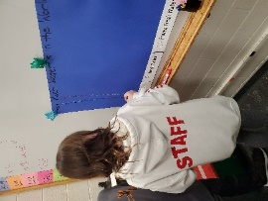
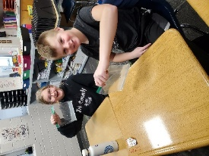
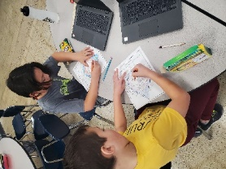

Sixth Grade News

We have been learning all about personal narratives in 6th grade Language Arts! We had fun reading examples and learning about the components that make up a strong personal narrative. Students then had the opportunity to brainstorm about events and people that have made strong impacts in their lives. This brainstorming led to some great topic choices! Students have been working hard in the writing and editing process, learning new tips and tricks on their Chromebooks along the way. We are so thankful for stories and how these stories can shape us. We praise God for being the Author of our life stories - we pray that we would give Him the glory in every chapter!
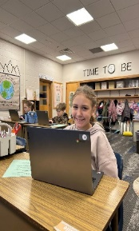
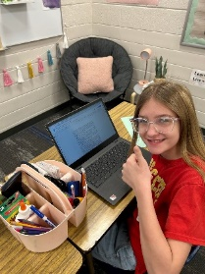
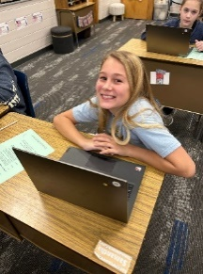
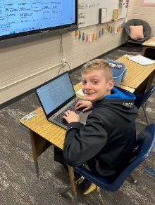

Third Grade News
Third graders have been learning about economics and personal finances. They participated in a budgeting simulation at the beginning of our social studies unit, and then we did a small business simulation. Students were divided into small groups. Each group chose a product to manufacture. They had class time to make their products and design a sign for their business. Each store was “leased” from Mrs. Wiekamp. All production supplies were “purchased” from Mrs. Wiekamp (hmmm… maybe not so “real world”). Younger students were invited to “Wie-Mart” to shop in its stores. These students were all given $5 to spend however they wanted.

Following the sales, store owners completed an expense form and totaled their profits. We discussed supply and demand, profit and loss, and scarcity. Third graders did a great job of realizing which products took a longer time to make and should therefore cost more, but not charging enough could cause a loss in profit.

Pictured below are the third graders with their store signs, and the 2nd graders who purchased their products.
SAGG’s Bracelets PKA Bookmarks STE Paper Airplanes
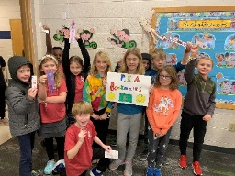
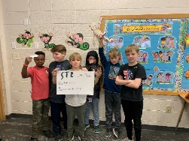
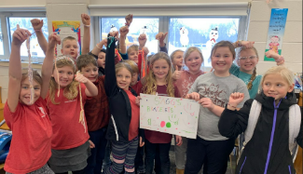

Band news

NEW INSTRUMENTS

At our Pancake Breakfast this past September the band raised money to purchase a few instruments.

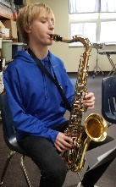
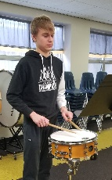

Jacob Van Meeteren playing a new Snare Drum Preston Louters playing a new Tenor Saxophone

Students attend Strong Foundation Band
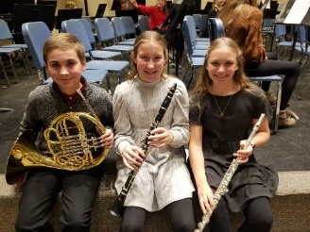
On January 16th, Lacey Petitt, Evan Runia, and Annie Schemper from Sheldon Chrisitan performed at the 10th annual Strong Foundations Honor Band in Sioux City North High School. This honor band is unique because it is for 6th graders. Most honor bands are for 7th and 8th grade and High School. The purpose of the Strong Foundation Honor Band is to provide an opportunity for young instrumental musicians to have an excellent ensemble experience in a positive, friendly environment without competition or unnecessary stress, while working with outstanding musicians. It is a great opportunity for young 6th graders to play with other talented musicians from 33 schools represented all over Siouxland! The directors that directed the two bands were Jeana M. Larson, formerly the Sheldon MS Band Director, and Jason Rygg of South Dakota. Stacie Pepin and the Sioux City North school systems did a great job organizing and hosting this event. With over 200 participants, the auditorium was a packed house.

Music News

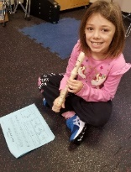
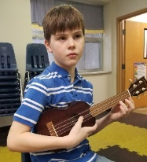
We have had a busy fall with our students performing a Veterans Program in November and a Christmas Program in December. After the Christmas break students have been busy with a variety of musical topics. Our Kindergarten and first graders have been doing a unit on “Peter and the Wolf” while our second grade students have enjoyed starting our Bucket Drumming series. The third grade students are preparing to start the Recorder Karate songs and our fourth and fifth graders are learning all about the instruments in an orchestra. Folk music is the topic for our Junior High, exploring the recorder, ukulele, and voice with folksongs preparing for a program in the spring.
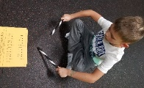
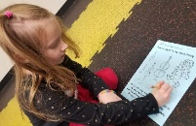

Clara Miller “Peter and the Wolf”
Kendall Heynen Bucket Drumming Aubrie Koerselman Karate Recorder Gus Dunn ukulele

Sixth & Seventh Grade Social Studies
Racing Across Latin America

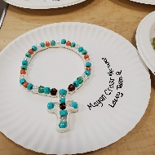
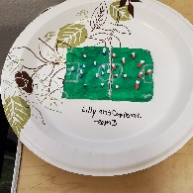
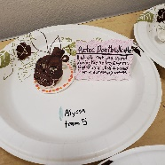
If you step into the 6/7 Social Studies room, you will see a variety of models, posters, and pictures. These represent only a small portion of what the students have been learning in their Race Across Latin America, or RALA. Six teams are competing to gain the most points and win the privilege of breaking open the pinata at the end of the race. The race consists of three rounds---Mexico & Central America, the Caribbean, and South America. Students learn about the country, its geography, people, and culture by researching and creating. Each round concludes with a team competition. Winner takes all, but everyone will get to take part in the Fiesta!

SCHOOL BOARD INFORMATION

January 11, 2023 (condensed notes)

1. Opening prayer and devotions by Brett Vander Veen
2. New Business & Committee Reports
- Board members discussed Chapter 5 -Leadership Decision Making from the book “Guiding Schools to Flourish”
- 2023-2024 Board Nomination format was discussed
- 2023-2024 School calendar was approved
- Snow Make-up days (hours) have been approved with:
1-four days were built in to original schedule
2-Wednesdays will be full days for remainder of school year with a couple possible exceptions, thus making up 2.8 days
3-February 20 & April 6 will be snow makeup days
IF NEEDED:
4-May 25 will be full day (no 12:15 dismissal)
5- May 26 full day
6-April 10 (Easter Monday)

- Staff stipend for Curriculum revision and completion during summer
- Investigating renovation to old bathrooms on west end of school
- Finance committee will be distributing NICSTO and Tuition Assistance Funds in February, monthly report was given: income - $79,418.42, expense - $69,895.44
- Reviewed policy on Government regulations and school calendar
- Updated Fire Inspection report
- Cleiton Zanela closed with prayer
Next meeting Wednesday, February 8, 2023 at 7pm

