**Welcome New Students**

We would like to give a special welcome to all of our new families this year!



Angel & Dina Escobar - Valeska (P) & Kiana (K)

Dan & Kathy Poppema - Lael (P)

John & Brooke Oldenkamp - Lydia (P)

Sam & Jennifer Kooiker - Aubrie (7th)

Welcome to SCS. We want to wish you God's blessings as you become a part of our school.

**School Theme**

Philippians 1:6 “Being confident of this, that he who began a good work in you will carry it on to completion until the day of Christ Jesus.”

September: The Need

October: Blue Print

November: The Foundation (trustworthy)

December: The Architect (imitator of Christ)

January: The Worker (grateful)

February: The Crew (encourager)

March: The Foreman (respectful)

April: The Tools (self-control)

May: The Ribbon Cutting

**Open House and Supper**

The SCS Auxiliary will be putting on an Open House Grill Out on Tuesday, October 29. Come to see the progress of the school, the students' handiwork in the classrooms, and some great food and fellowship!

*Open House: 5:00-6:30*

*Supper: 5:30-7:00*

**Veterans Day Program**



Sheldon Christian School will be having a Veterans Day Program on Monday, November 11, at 8:45 A.M. This is a great opportunity for our students to gain an appreciation for what our veterans have done for our country. Everyone is invited, but we want to offer a special invitation to veterans and their spouses.

**Welcome Mrs. Granstra**

Hello! My name is Brooke Granstra. I am very excited to be teaching at Sheldon Christian as the preschool teacher. It is such a blessing to teach at a school whose staff, families, and students serve the Lord through everything they do! I am excited to help my students grow to know and love God through the various activities we do at school. I grew up in Sioux Center, where I attended Sioux Center Christian School, Western Christian High School, and went on to Dordt College. I earned a bachelor’s degree in elementary education with an early childhood and coaching endorsement. Before teaching at Sheldon Christian, I taught preschool at Sanborn Christian. I currently live in Sheldon with my husband Jeffrey Granstra who works at People’s Insurance. We have a two year old son, Wyatt, and have recently been blessed with a beautiful daughter, Briar. When I’m not at school, I enjoy exercising, being with my family, and spending time with friends. Being a new mom, I have recently added new hobbies such as grabbing an ice coffee from McDonald’s and going to the park! I am so thankful to be serving at Sheldon Christian and can’t wait to see God’s workmanship through the way he created each student!

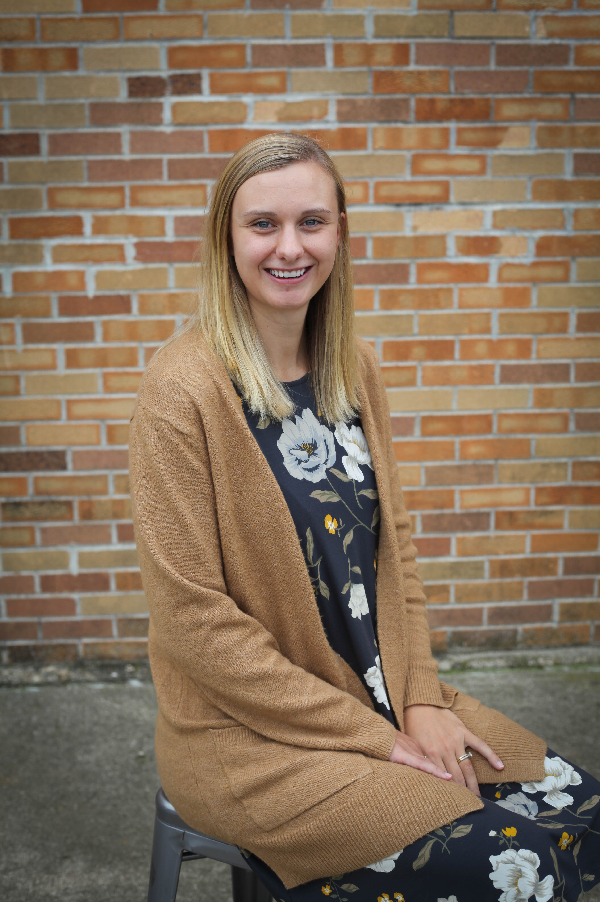

**Asbestos Compliance**

**Information**

In compliance with regulations of the Environmental Protection Agency (EPA), parents, teachers and all employees are hereby notified that Sheldon Christian School has a management plan for asbestos available in the school office, should anyone desire to see it. Areas that contain asbestos are given the required periodic surveillance.

**SCRIP**

Scrip is off to a great start this school year! Way to go participating families! If you have registered, but haven't been ordering regularly, that's OK!  Paper orders can be turned in any school day of the week, but will be processed on Mondays. All participating retailers are listed at [www.shopwithscrip.com](http://www.shopwithscrip.com/). If you would like to participate and haven't signed up yet, contact Julie Jacobsma at sheldonchristianscrip@gmail.com or 712-441-5091 for registration information, or stop by the school office.

**Kindergarteners Learn**

**About Monarchs**

Charlene Elyea, the Obrien County naturalist, met the kindergarten students at the bike trail to teach them about monarch butterflies. She talked about how the monarchs are migrating to Mexico for the winter. She showed them which kind of butterfly to look for and how to tell if the monarch was a boy or girl. The boys have an extra spot that Mrs. Elyea calls their “suitcase of smells” and the girls have darker lines that she calls their “make up!” Mrs. Elyea gave the students a net to catch monarchs. They caught and tagged 13 monarchs that will hopefully make it to Mexico!

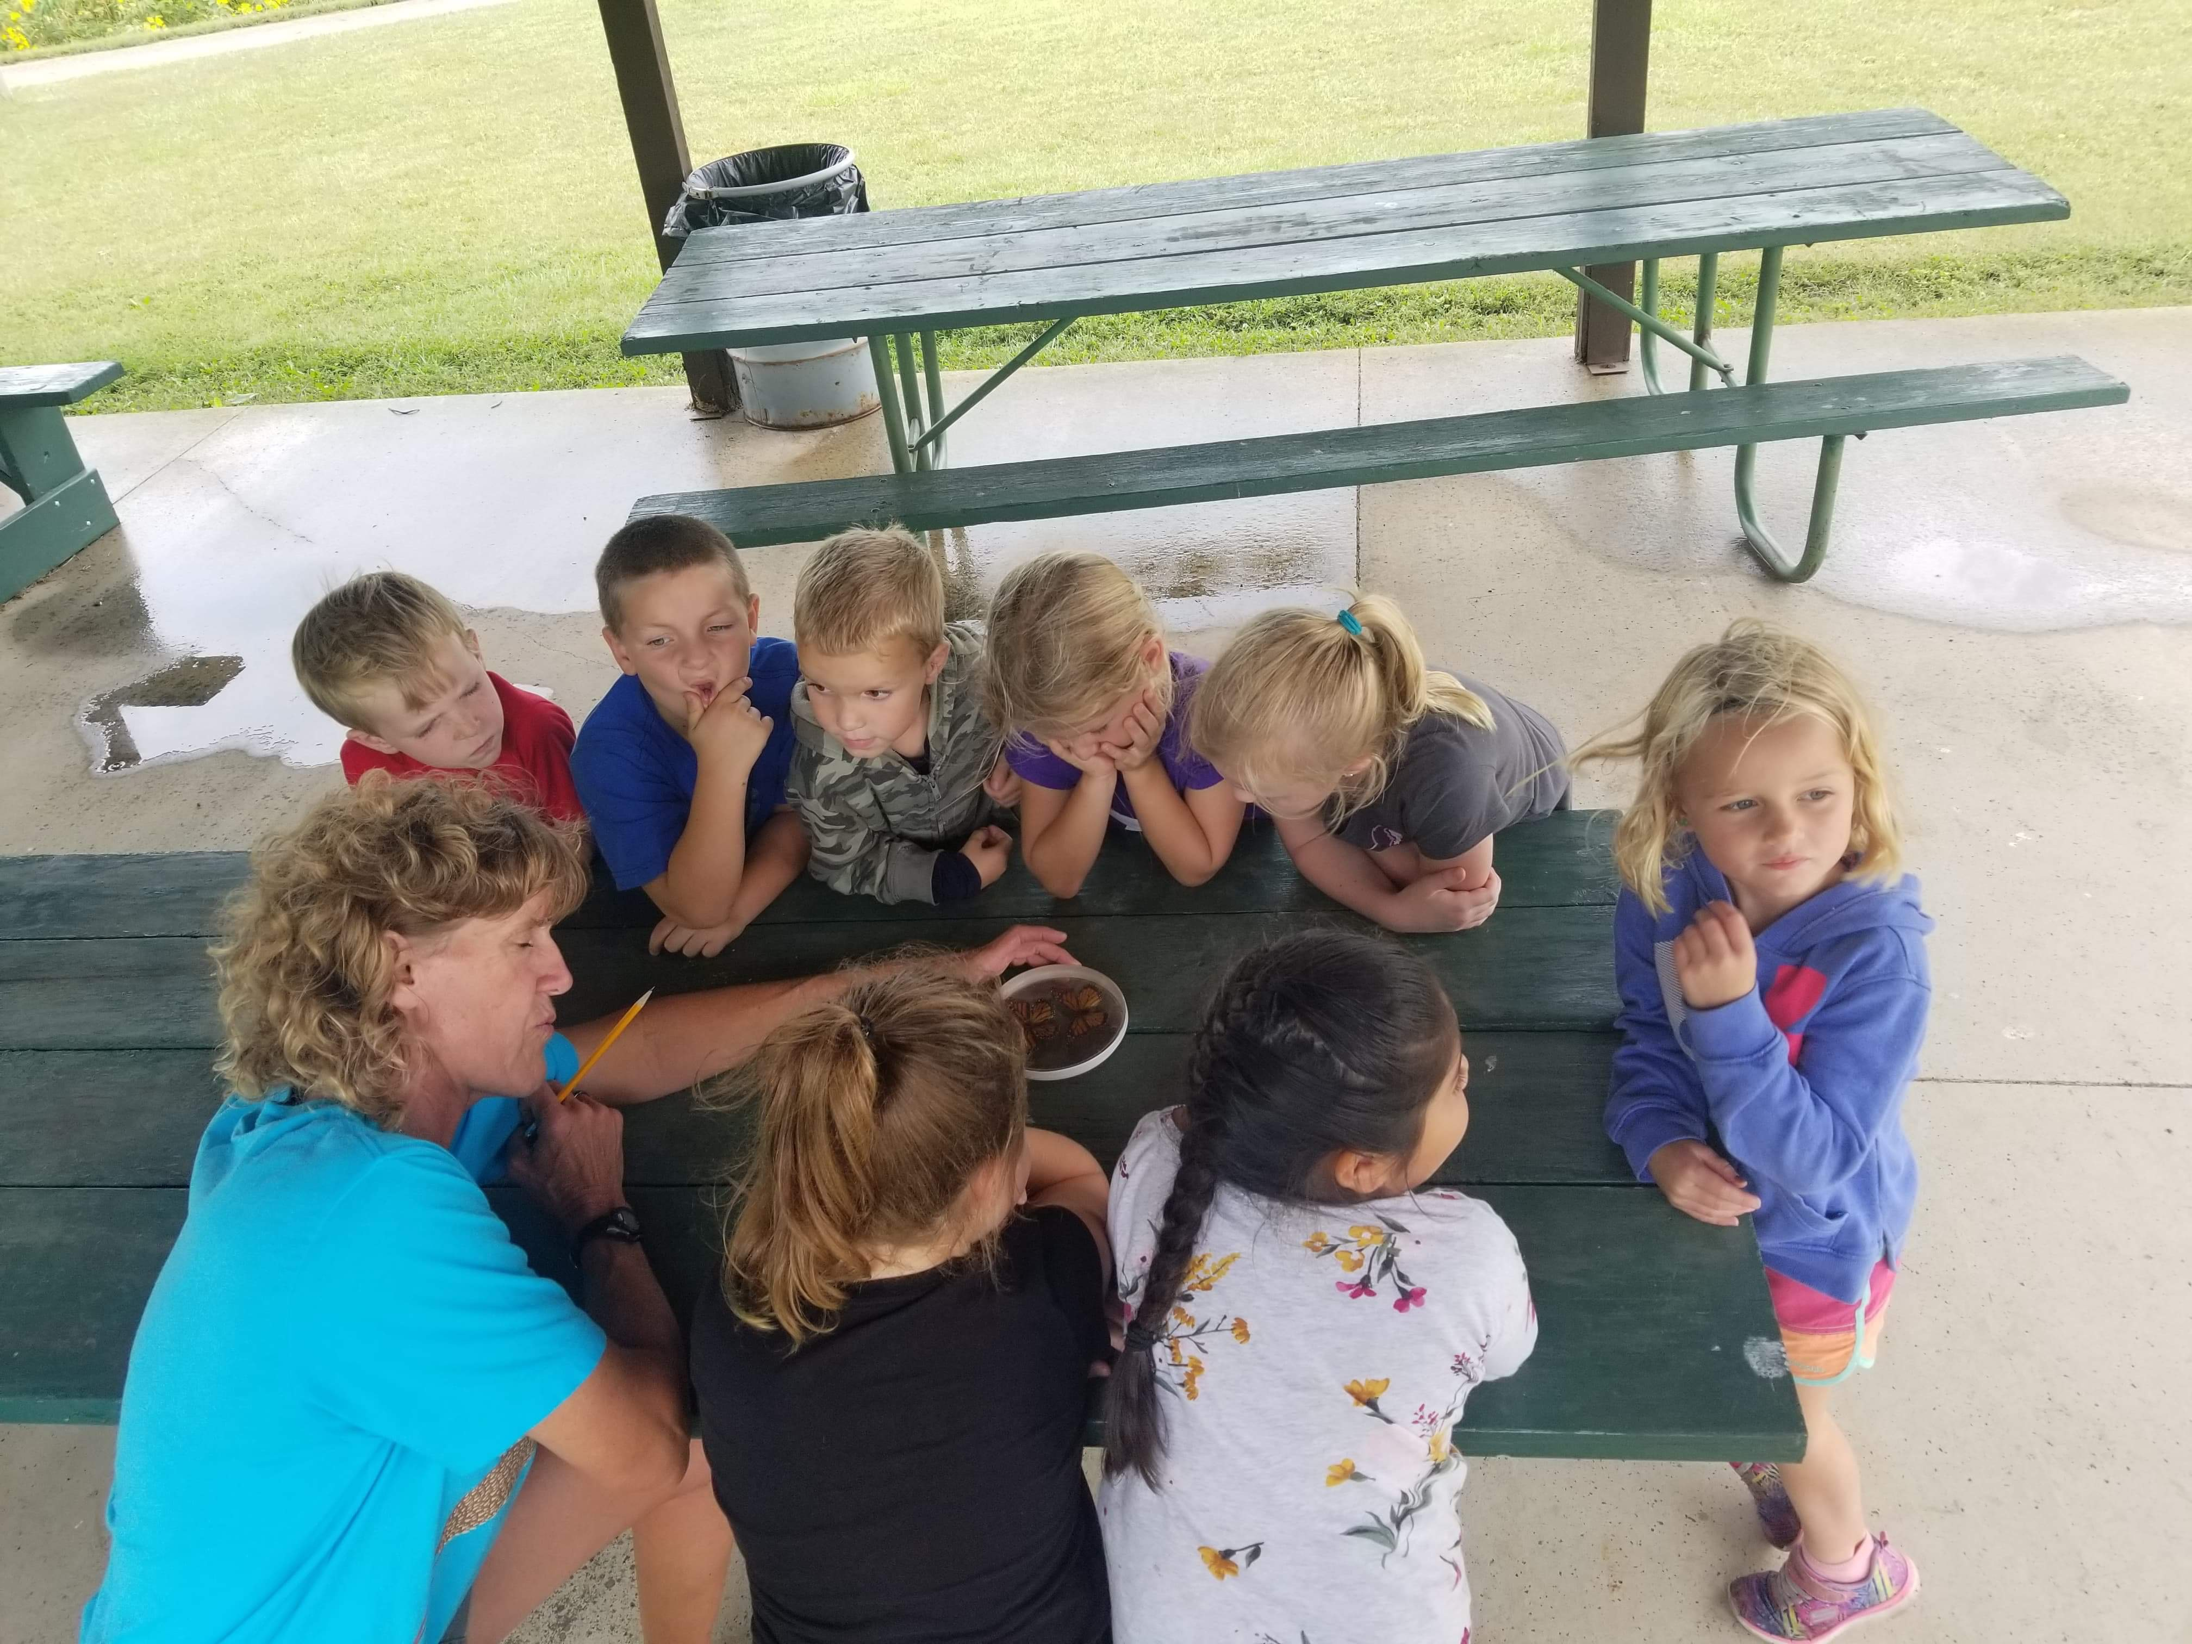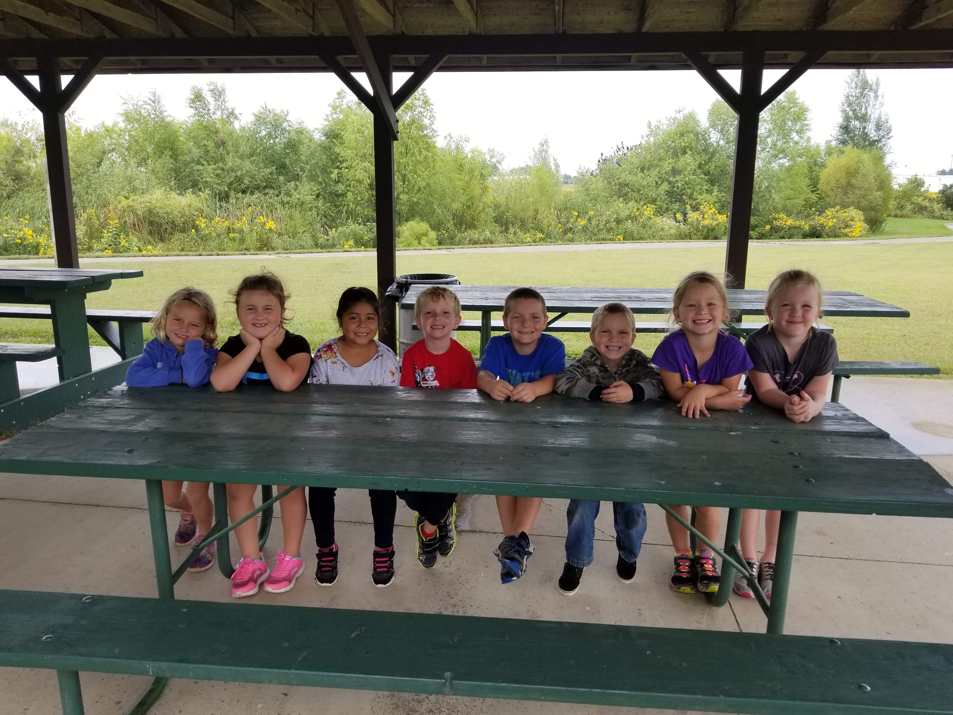

**Board Officers and Committees**

**President---------------------------------------**Phil Louters

**Vice-President------------------------------**Mark Wieringa

**Secretary**------------------------------------------Lora Petitt

**Treasurer---**--------------------------------Evan De Hoogh

**Finance -------------------------------------**Evan De Hoogh

Kyle Heynen

Tom Wibben

**Education---------------------------------------**Phil Louters

Tom Wibben

Lora Petitt

**Building Grounds ------------------**--Wade Heemskerk

Lennis Harberts

Mark Wieringa

**Promotion-------------------------------**Cherish Granstra **Technology----------------------------------**Kyle Heynen

Lennis Harberts

**Foundation---------------------------------**Mark Wieringa

**Fundraising**-------------------------------Cherish Granstra

**2nd Graders Attend Farm Safety Camp**

On the afternoon of September 13, the 2nd graders took a walk over to the Sheldon High School to attend Farm Safety Camp. This camp is put on by the high school’s FFA and Sanford Hospital.

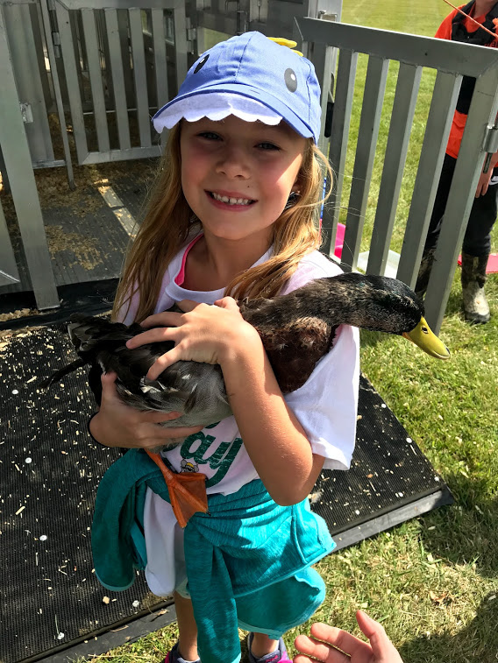

They were attending along with 2nd graders from East Elementary and Sanborn Christian.

Once they arrived at the school, they were put into smaller groups with a leader. The leader directed them to the different stations lead mostly by the FFA students. Some of the stations were animal safety, chemicals, electrical safety, tractor and PTO safety, and ATV safety. When asked which station was their favorite, a variety of answers were given, but electricity and animals were probably the most favorite.

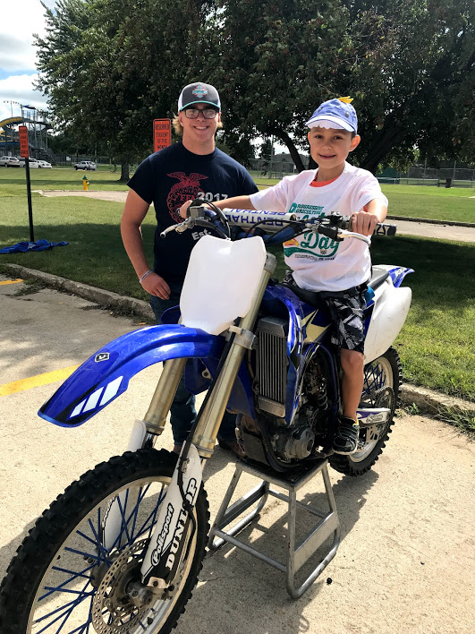

It was a great afternoon of learning, and we are thankful to the FFA and the hospital for the invitation!

**Faculty for 2019-2020**

**Teachers**

Mrs. Brooke Granstra---------------------------Preschool

Mrs. Starla Geels------------------------------Kindergarten

Mrs. Kaly Hale------------------------------------1st Grade

Mrs. Lori Dykstra---------------------------------2nd Grade

Mrs. Tonya Wiekamp----------------------------3rd Grade

Mrs. Julie Jacobsma------------------------------4th Grade

Mrs. Kelly Vander Bush-------------------------5th Grade

Mrs. Lauren Roose-------------------------------6th Grade

Mrs. Alyssa Postma-------------------------------7th Grade

Mr. Pete Van Velzen-----------------------------Principal/

8th Grade

Mrs. Barb Stuit--------------------------------------- Music

Mrs. Amy Runia-------------------------Resource Room

Mr. Nate Schreur----------------------Physical Education

**Support Staff**

Mrs. Jena Dykstra---------------.Administrative Assistant

Mrs. Sue Meyers--------------Preschool Paraprofessional

Mrs. Jill Van Essen----------------------------Head Cook

Mrs. Charm Neeley------------------------Assistant Cook

Mrs. Julie Jacobsma-------------------SCRIP Coordinator

Mrs. Helen Van Dyke----------------------------Librarian

Mrs. Jennie Rosales------------------------------Custodian

Miss Arlene Westerveld------------- Foster Grandparent

**NICSTO**

Sheldon Christian School is a part of the Northwest Iowa Christian Schools Tuition Organization. NICSTO collects money from private donors to help qualified families meet their tuition obligations. In exchange for their donations, contributors receive a 65% tax credit on their Iowa income tax. In addition, 35% of the donation can be claimed as a tax deduction on their federal taxes.

Sheldon Christian School needs to raise approximately $64,200 in donations **before December 1** if we are to receive our entire allotment of scholarship funds. So far we have raised about half the needed funds. **Please consider giving to this worthwhile cause.** Contact Pete Van Velzen (712-324-2429) if you would like to donate to NICSTO or receive additional information. If you have friends or family members who might be willing to donate to NICSTO, please share this information with them. Attached to the newsletter is a form to fill out and return with your donation.

**Harvest Festival**

The first grade class went to the Harvest Festival in Sioux Center on Friday, September 13. While at the festival, students participated in an active investigation about what life was like in the 1900s. Students helped press apples for apple cider, imagined going to school in a one-room schoolhouse, practiced rope making, visited a sod hut replica, observed a working blacksmith, toured a reconstructed peg-barn, visited a small church and much more.  The activities centered on the early 1900s farm and town at the Sioux Center Fairgrounds. Students were encouraged to ask questions and imagine living during the 1900s.

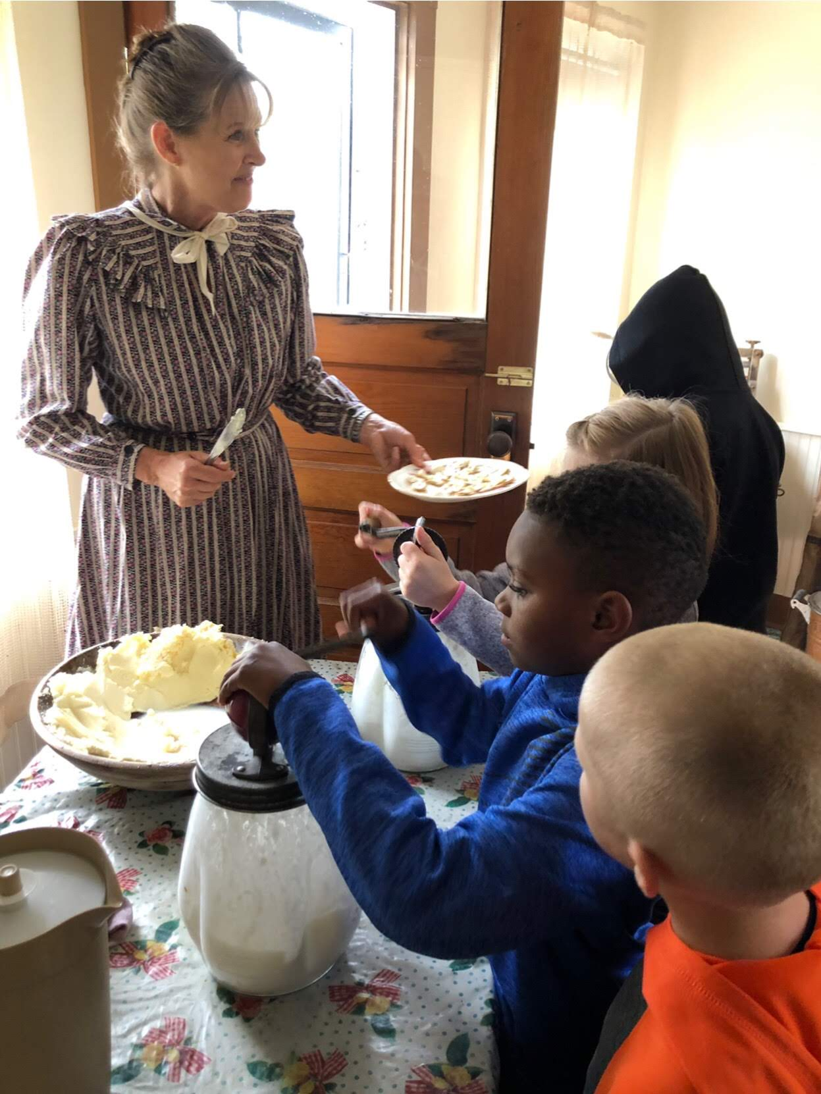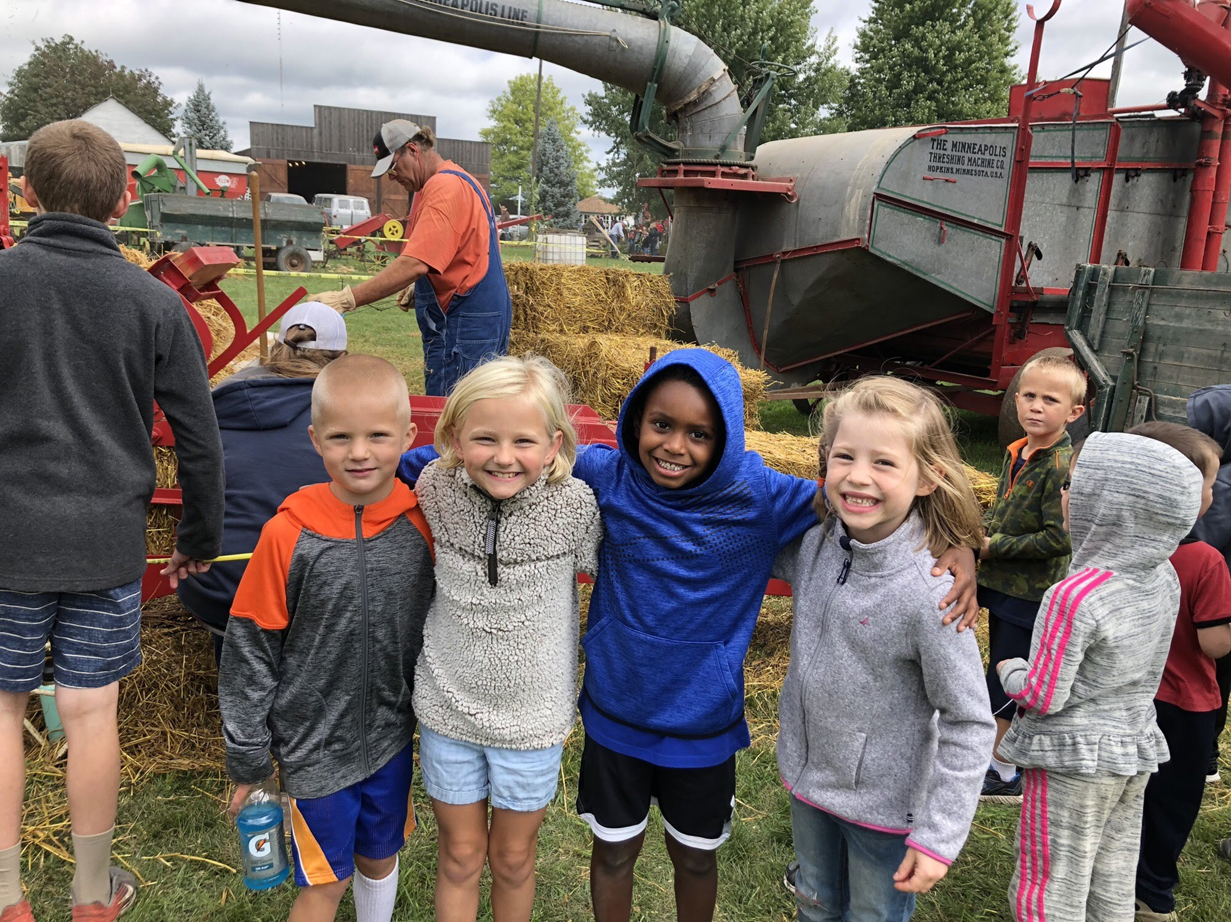

**Advance Notices**

P/T Conferences - November 12 &14

Christmas Program - December 10

Auxiliary Basketball Tournament - Dec. 13 & 14