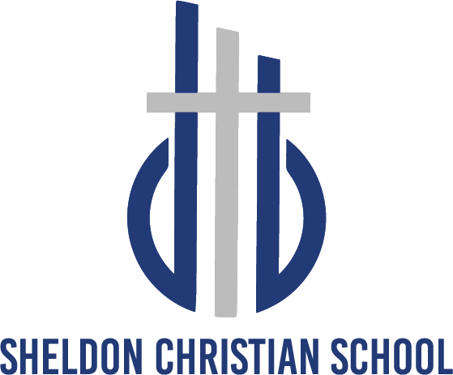

A.MISSION STATEMENT:
Sheldon Christian School prepares God’s children for a lifetime of Kingdom service by providing quality God-centered education.

- AIM AND PURPOSE OF SHELDON CHRISTIAN SCHOOL

- To prepare the child as an image-bearer of God for meaningful participation in society.
- To enable the child to see his/her life’s calling in the context of the Kingdom of God.
- To show the child the way to total commitment and surrender to Christ.
- To guide the child in understanding that the radical consequences of such a commitment affects all areas and relationships of life.

- PHILOSOPHY—WE BELIEVE THAT

- The Bible God’s inspired, infallible revelation of Himself,
the nature of man and creation,
His redemptive plan through Jesus Christ on man’s behalf,
and His will for mankind.
(II Timothy 3:16-17, Psalm 111:10, James 3:17)

- Triune God Father, Son and Holy Spirit,
the Father is creator and sustainer of the universe,
the Son is Savior of those who, through grace, believe in him,
the Holy Spirit dwells in our hearts to motivate us to seek God and serve him.
(Genesis 1:1, John 3:16, I Corinthians 2:12)

- The World Created perfect, but distorted by man’s fall into sin.
Only Christ’s redemptive work can restore all of creation, including man, to the glorification of God.
(Romans 1:21, Ephesians 4:18, Romans 12:2)

- Education Process by which our children are led to see the entire word
as God’s handiwork and God’s plan of reconciliation.
Includes the development and expression of the whole child:
social, emotional, intellectual, physical, aesthetic, spiritual.
Enables the child to gain knowledge of God’s Kingdom and his/her
responsibilities as a child of the King.
Children of believers must receive an education which is firmly
rooted in the Word of God.
(Col. 2:3)

- The Students Created in the image of God,
The student requires an education which nurtures an
understanding of his/her privilege and responsibility as a disciple of Jesus Christ.
(Genesis 1:27, Romans 12:1, Matthew 28:19-20)

- The Teachers Guide every student in to a deeper understanding of God and His Creation.
Helping every student to perceive their unique opportunities to serve their Lord.
(Ephesians 4:11)

- The Parents Have the primary responsibility to provide a God-centered
education for their children because of God’s covenental
relationship with His believers.
This education should be carried out in the home, the church, and in schools whose purpose are consistent with the Word of God.
(Deuteronomy 6:6-7, Proverbs 22:6, Romans 12:5)

- Christian Community Embraces parents, children, and the larger body of Christians. Because Christian education contributes directly to the advancement of Christ’s Kingdom, it is the obligation of the entire Christian community to pray for, establish and financially support Christian schools.
(I Peter 2:9, Genesis 17:7, Acts 2:39)

