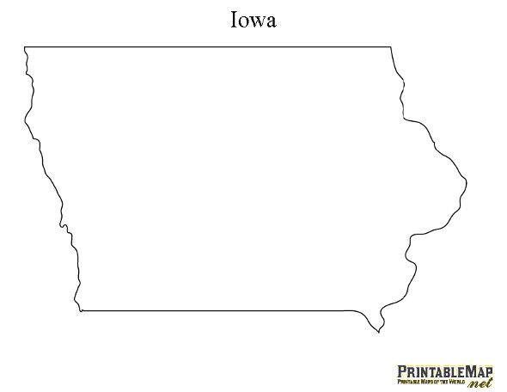

Did you pay Iowa income taxes this year?

Next year would you like to have your Iowa income taxes go to Sheldon Christian, Unity Christian, and Western Christian to help families with their tuition obligations and help pay down the debt we have on our building at the same time?

NICSTO allows you to do this with a 75% tax-credit. Two examples.

- If you have an Iowa income tax liability of $750, you could give $1,000 to NICSTO which would then provide Sheldon Christian, Unity Christian, or Western Christian with $1,000 to be used for tuition assistance. Then when you do your tax work in March/April you will receive a tax-credit of $650 from the state of Iowa. You could then give this $750 refund to Sheldon Christian, Unity Christian or Western Christian to help pay down the debt on our schools. Sheldon Christian, Unity Christian, or Western Christian benefits by $1,750 from your gift of $1,000 and you pay no Iowa state income tax.
Two gifts in one!

If you are at least 70 ½ years old, we encourage you to give from your IRA (you may even use your RMD) to NICSTO. If you give $1,000 from your IRA you don’t need to include it as taxable income on your return, If you are in the 15% tax bracket you save $150 in taxes you owe to the IRS plus what you save in Iowa taxes. Sheldon Christian, Unity Christian or Western Christian receives that $1,000 for tuition assistance AND you will receive a state income tax credit of $750 that you can use to help Sheldon Christian, Unity Christian, and Western Christian pay down the debt on their buildings.
Two gifts in one!

- If you have questions, feel free to contact Brad Vis at Western, Wayne Dykstra at Unity, or Marlin Schoonhoven at Sheldon Christian, or check with your tax preparer.

- Grain Donations are a great option as well specifically – grain cannot be sold and the check brought to the school, the SCHOOL NEEDS TO ACTUALLY SELL THE GRAIN. Over

ATTENTION
To receive a tax credit in 2022, please complete the form below and return it with your check. Available tax credits are limited by Iowa law (Checks received after NICSTO reaches it limit
will be returned).
N I C S T O
Northwest Iowa Christian School Tuition Organization

CONTRIBUTION MEMO

This completed memo must accompany your contribution.
A formal Iowa Tax Credit Certificate will be sent to you in
late December or early January.

__________________________________ ____________________________
Taxpayer Name Date of Contribution

_______________________________________________ ______________________________________
Address Amount of Contribution

_____________________________________________ _______________________________________
City State Zip Code

_______________________________________________ ______________________________________
Taxpayer I.D. No. (Social Security No.) Phone number

Name of the institution/school you wish to be the beneficiary of this donation_______________________________

Your contribution may be mailed or delivered to one of the following addresses:
Sheldon Christian
1425 9th St E
Sheldon, Ia 51201

Northwest Iowa Christian Schools Tuition ORG  811 7th St  Sheldon, IA 51201 | OR | One of the 16 Christian Schools  in NICSTO you identified as the  beneficiary of your donation.

