Sheldon Christian Scout
March 2021

Sheldon Christian School prepares God's children for a lifetime of kingdom service by providing quality God-Centered Education.

Principal's Corner
Feeling Blessed (personal reflection)
Feeling blessed that all teachers will be returning for the 2021-2022 school year.
Feeling blessed for the strong bond and cohesiveness of the teachers.
Feeling blessed for the Christ-like examples shown daily by our teachers to the students.
Feeling blessed for the love that is shown by our teachers.
Feeling blessed that our school has seen little to no effects of COVID-19 thus far.
Feeling blessed for no major health concerns for anyone who had the virus.
Feeling blessed that our board members are dedicated to the mission of Christian Education.
Feeling blessed that people recognize Sheldon Christian as an integral part of this community.
Feeling blessed that our students are engaged in achieving excellence in their academics.
Feeling blessed that students are able to have positive interactions with their classmates.
Feeling blessed that students are growing spiritually, discovering a heartfelt desire to serve God.
Feeling blessed that our students are excited to be a part of God’s kingdom.
Feeling blessed for all the new families that have entered our school doors this year.
Feeling blessed for all the countless volunteers that help at our school.
Feeling blessed that families are incredibly supportive of their children and the school.
Feeling blessed because of all the faithful supporters of Christian Education.
Feeling blessed for all the men and women who put countless hours into our fundraisers.
Feeling blessed that I have the opportunity to be an instrument for God to use in His plan.
Feeling blessed for all the help and support I continue to receive as I walk through this first year.
Feeling blessed for all our area Christian schools.
Feeling blessed that I continue to grow personally in my spiritual walk.
Feeling blessed that I have been blessed with a wonderful Christian spouse and children.
Feeling blessed that God allows me to serve.

Upcoming Activities

- April 1 - 5 - Spring Break
- April 27 - 6th - 8th grade Spring musical; "Disney Night"
- May 11 - K-5th spring musical & GRANDPARENTS day!

Guess what! You can now easily donate to Sheldon Christian by a click of a button! The Sheldon Christian Website now has paypal!

Sheldon Christian Geography Bee
This year, there was no National Geography Bee. But we did have a Sheldon Christian Geography Bee! There were two participants from each grade.
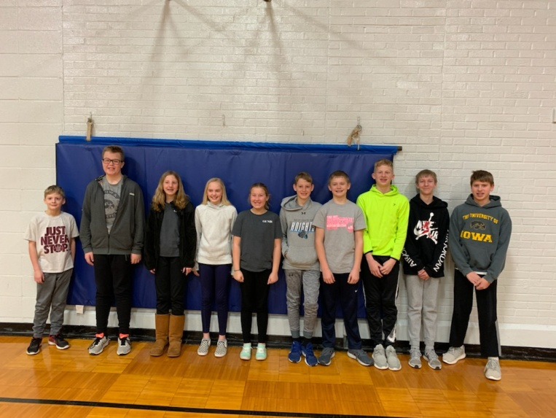
From left to right -
Eddie Wieringa (4th), Josh Petitt (7th), Alyssa Schmidt (5th), Lilly Kamstra (5th),
Lacey Petitt (4th), Elijah Schreurs (6th),
Kolby Heemskerk (7th), Joey Wieringa (6th), Jace Kleinwolterink (8th),
Michael Wassenaar (8th)

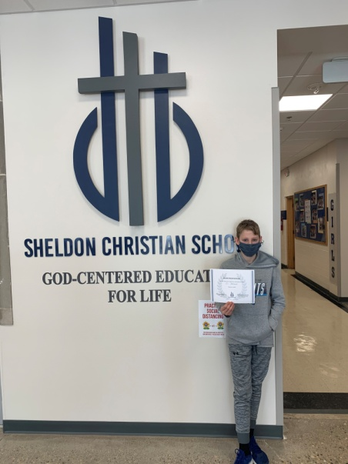

The two finalists were Eddie Wieringa (4th) and Elijah Schreurs (6th).
Elijah Schreurs was the champion!

Congratulations to all the kiddos!

SCS Basketball
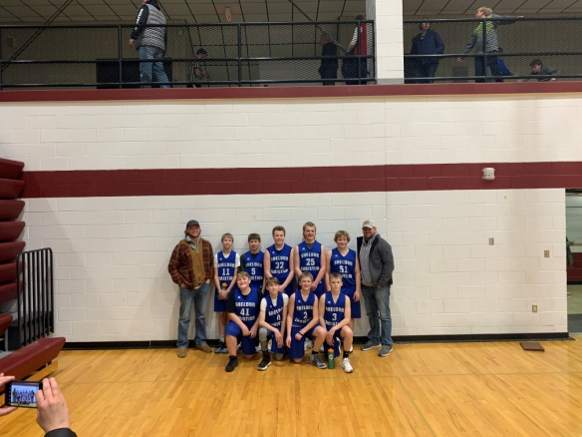
This year the Sheldon Christian boys basketball team consisted of four 8th graders, five 7th graders, and six 6th graders. We had enough players this year to have a 7th and 8th grade team, with the seventh graders playing on both teams. Between covid protocol and the snow we had a few less practices and games than we would have liked, but we were glad to still have a season. Our sixth and seventh graders only got to play 3 games this year, but they played well winning 2 of the 3 games. Our 8th grade team continued to improve throughout the year, and it showed as we ended the year by winning the end of year tournament at Western Christian! It was great to see everyone improving individually, but even better to see them come together as a team as the season progressed. I’d like to thank the 8th graders for their leadership and hard work throughout the entire season.
Team Pictured: Coach Ben Granstra, Jace Kleinwolterink, Michael Wassenaar, Josh Petitt, Chris Freese, Christopher Vande Brake, Coach Jake Granstra
(front) Matthew Wiersma, Cameron Nieuwenhuis, Kolby Heemskerk, Mason Dykstra

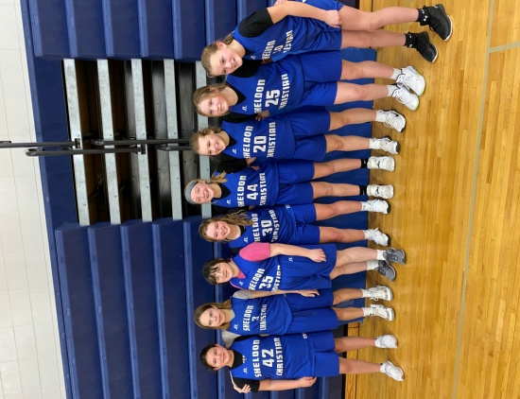
Our Sheldon Christian Meteor Girls basketball team had another awesome year! With only four 8th grade players and five 6th grade players, we played an 8th grade schedule only. We did very well. We were 3-2 during the regular season and 2-2 in the tournament. In the tournament, we won our first game, lost our second game, won our third game and lost our fourth game putting us in 4th place. We played very well but its always hard for the 8th graders to end their season knowing that was their last basketball game playing for Sheldon Christian.
With only two practices before our first game because of Covid restrictions, we didn't have a lot of time to work on fundamentals so the beginning of our season was a work-in-progress. We also missed two games because of the snow storm in January. It was fun to watch the girls learn and understand the game as the season went on. Every girl played an important role on the team. Our theme Bible verse was Colossians 3:23, "Whatever you do, work at it with all your heart, as working for the Lord, not for man." We talked about when we practice or when we play a game, if we play for the Lord and not for ourselves or others, our attitude will change. We will strive to always do our best!I would like to thank our 8th grade players - Sammie, Laina, Aubrie and Olivia for their leadership throughout the season! They were always encouraging and a positive influence on the other players and were always a joy to be around! Thank you again and best wishes for next year! You will be missed!
I would like to encourage every 5th, 6th and 7th grade girl to go out for basketball next season and to begin practicing now for next season. We look forward to seeing you!
Thanks again Ladies! Coach Harberts
Girls pictured above: Dani Mastbergen, Olivia Van Maaren, Alivia Miller, Samantha Holz, Sydney Holz, Aubrie Kooiker, Laina Stuit, Avery Dykstra
Classroom Happenings

7th Grade Happenings

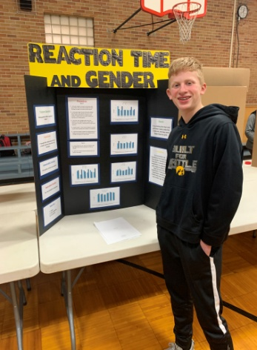
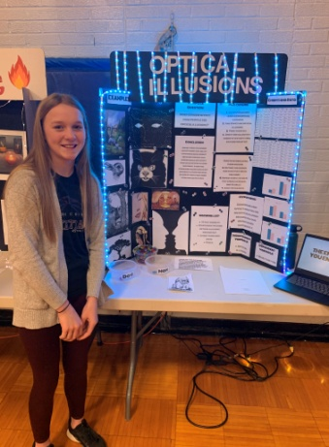
Does music genre affect the number of eggs chickens lay? Does gender affect reaction time? Does temperature affect germ growth? These questions (and many more!) were answered by the 6th & 7th graders at the annual Sheldon Christian Science Fair. Beginning in January, students learned about the scientific method in science class. Through a variety of hands-on activities, students learned the importance of developing a strong purpose question, hypothesis, procedure, materials list, independent variable, dependent variable, and conclusion when conducting an experiment. Students learned skills like making data charts and graphs on the computer. In language arts class, students wrote a research paper on a scientific topic related to their science experiment. They learned how to find reliable sources, take notes, put what learned into their own words, and give credit to their sources. On February 23, students had the opportunity to share what they had learned with the school community. School board members, parents, and friends of Sheldon Christian gathered to view the students’ project and celebrate their learning. Throughout this process, it was so fun to see students reflecting on God’s creativity and power shown through His amazing creation. We are thankful for a school where we can study God’s world and use our gifts to serve Him!
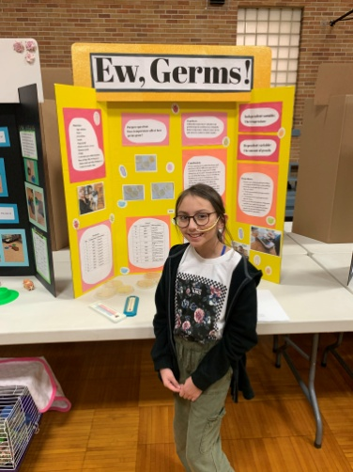
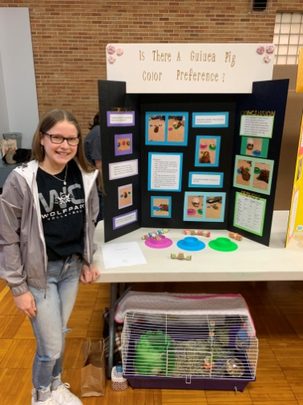
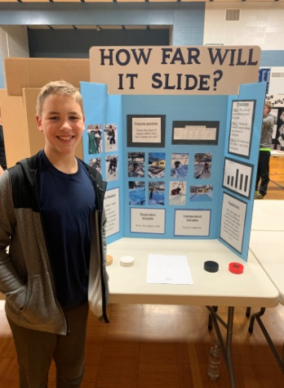

Ella Wibben Mayah Rosales Cody Schemper
Pictured above: Avery Dykstra (left) & Joey Wieringa (right)

5th Grade Wax Museum - 5th graders had the opportunity to choose and research a famous person from history. There was one important requirement: It must be someone that has made an impact in our world. The students were very clever with their choices this year! They had to research, write a paper, create a board, memorize a speech, and dress up as their character. It was a lot of fun to see history come to life at the wax museum!
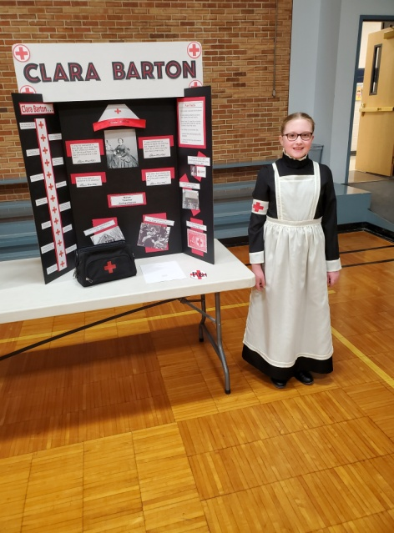
Joseph Borer: Zhang He
Cambree De Hoogh: Mary Ingalls
Carly De Hoogh: Laura Ingalls Wilder
Nayibe Diaz: Sacagawea
Caitlyn Freese: Martha Washington
Aftyn Habben: Annie Oakley
Ahbea Harberts: Michael Jackson
Aysha Harberts: Ora Washington
Annika Huisman: Clara Barton
Lilly Kamstra: Shirley Temple
Bentley Lucas: Kobe Bryant
Alyssa Schmidt: Marie Curie
Maddie Van Tilburg: Princess Diana
Micah Zeilenga: Clarence Best
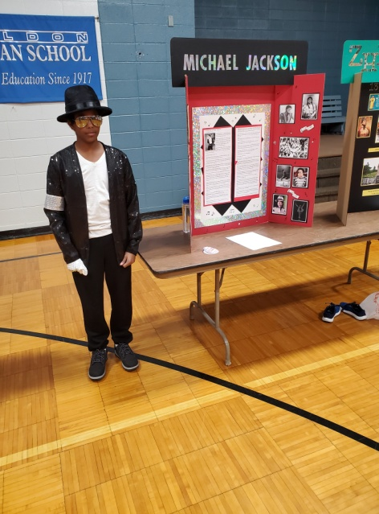
Annika Huisman as Clara Barton

Ahbea Harberts as Michael Jackson

8th Grade History Fair
The eighth grade class presented their History Fair Projects on February 23 in the Sheldon Christian School gym. The History Fair was in conjunction with the Fifth Grade Wax Museum, Sixth and Seventh Grade Science Fair. All ten students presented a specific project of their own choice. The student was required to research, formulate a topic, main idea, conclusion and thesis statement for their writing portion of the fair. They also had to make a display board with proper evidence of those pieces of information in their report. The students also presented physical artifacts and items that explained their project with visual detail. The students were required to present their project to two judges during the day who rated all the aspects of their projects. The students were then able to present their projects to family and friends at an open house in the evening. The attendance was greatly appreciated, the families got to see and hear a lot of historical information throughout the night.

Matthew Wiersma, Laina Stuit and Olivia Van Maaren proudly show their boards.
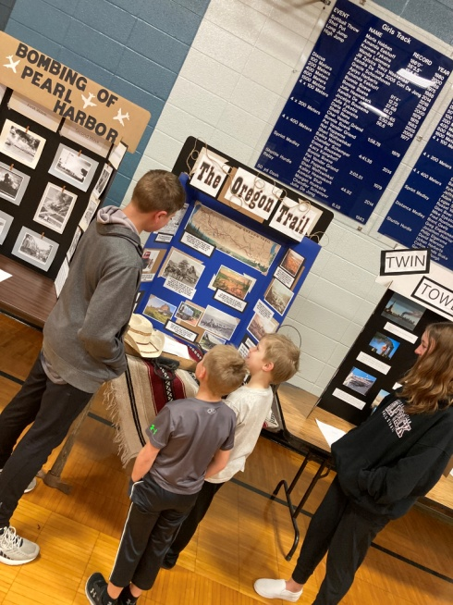
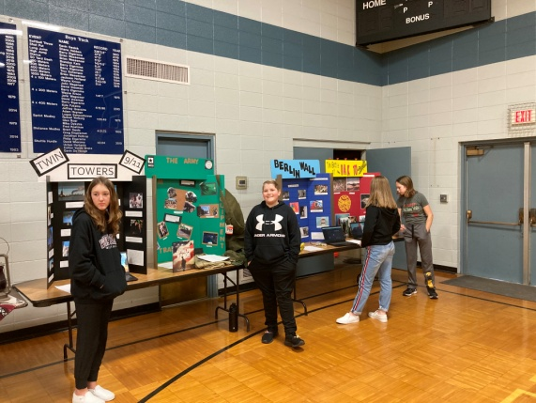
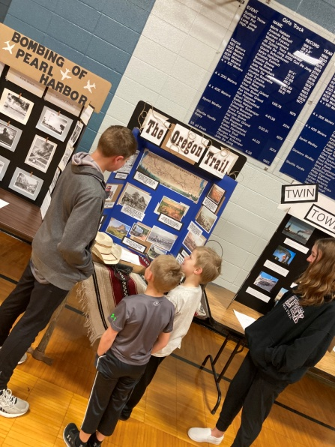
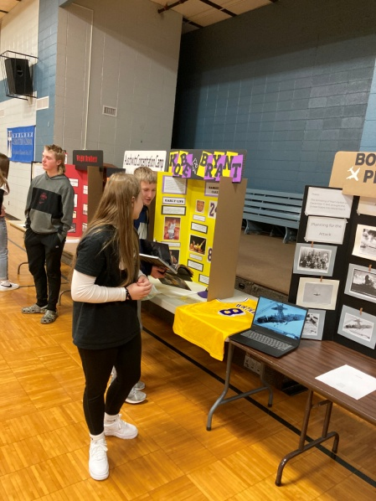
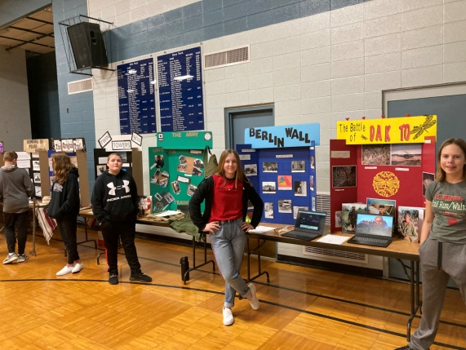
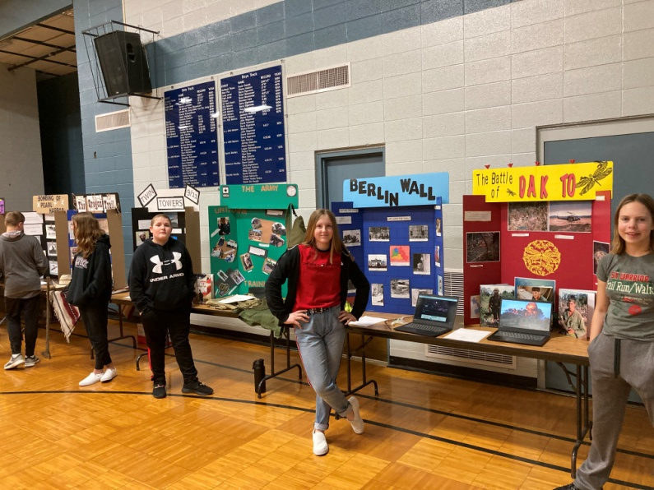

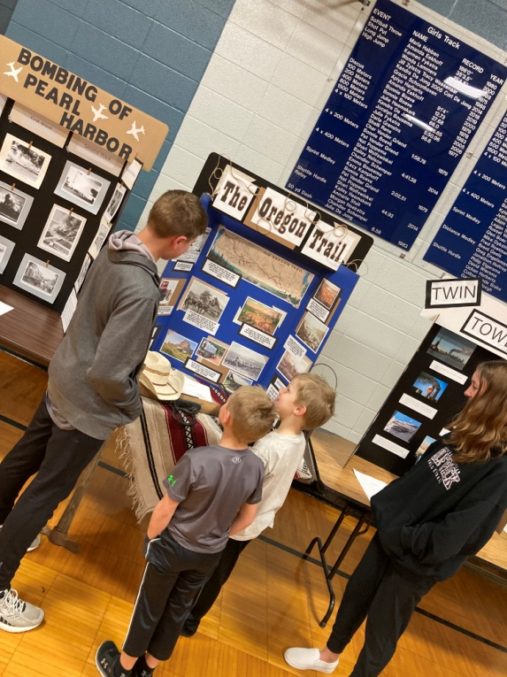
Michael Wassenaar showing Luke Wassenaar & Hunter Vander Veen his board about The Oregon Trail

Board Meeting Minutes - Monday, February 8, 2021
I. Opening Devotions-Lennis Harberts
II. Approval of Agenda
III. Approval of Minutes – January 11, 2021
IV. Policy Review #732-746
- MMSC to strike “curriculum coordinator” as well as “principal” and replace them with “the head administrator” in the board policy handbook.
- Marlin also handed out reading material, “Some Things Board Members Should Know-About Teachers and Other Staff Members”.
V. Old Business for Information
a. Professional Staff Church Membership-MMSC to move this change forward, MMSC to
present this at the next regularly scheduled (June 9) Society meeting
b. Joint Executive Committee meeting with Sanborn Christian for continued positive
support of each school, promote the other school, joint use of Assessments, and joint
use of staff
c. Accreditation Strands-secretary is hyperlinking data that has been completed in all the
strands
VII. Principal and Committee Reports
a. Principals report highlights
- Theme of the month “Goodness”
- Grade 6 & 7 completed their state testing for Future Problem Solvers, wait to
see if they qualify for state competition
- Parent -Teacher Conferences on Feb 9 & 11
- Attended Sheldon Community Safety meeting
b. Building & Grounds
- Directional street signs for school on Highway 18 and Washington Avenue will be going up soon
c. Education
- Professional work day on March 31 all teachers will be working on completing Social Studies curriculum revision
- Preschool/Kindergarten open house was held on March 11, 2021
e. Finance
- Income: $87,138.37
- Expenses: $60,809.24
VIII. New Business
a. 2021-2022 Finance recommendations for salaries & tuition was presented
b. 2021-2022 Budget was presented
c. 2021-2022 School Calendar draft was presented
d. Board Nominations were discussed
IX. Closing Prayer -Cleiton Zanela

Board Meeting Minutes - Wednesday, March 10, 2021
I. Opening Devotions and Prayer– Cleiton Zanel
II. MMS to approve the agenda. Motion Carried.
III. MMS to approve February 8, 2021 minutes. Motion Carried.
IV. Policy Review – Reviewed #747-760
V. Old Business for information:
A. Professional Staff Church Membership, MMS present at the next regularly scheduled (June
2021) Society Meeting. Motion Carried.
B. Accreditation Site Visit set for week of October 11-15, 2021 (two-three days)
C. 2021-2022 Budget
VI. Principal and Committee Reports
A. Principal’s Report was received for information. Highlights noted:
- Janelle Vander Zwaag has agreed to fill in for Brooke’s maternity leave.
- Social Studies Curriculum – completion target date is the end of this school year.
- March theme “faithfulness” and how that is being shown in our classes
- Wax museum, Science Fair, History Fair was a great success for all students in grades 5-8,
and well attended by families and friends
- 2 doses of Moderna vaccine has been given to all staff that signed up
B. Building & Grounds Committee
- Extension was given to custodians.
- Lawn mowing – the committee is looking into who will be doing the mowing.
C. Education Committee –
Preschool/Kindergarten open house – 5 families attended.
- All teachers have signed contracts for the 2021-2022 school year.
- MMS to approve the 2021-2022 proposed calendar from the Education Committee.
Motion Carried.
D. Finance Committee
- Financial Report: February 2021
- Income: $120,810.35
- Expense: $60,185.91
E. Technology Committee – 10 new Chromebooks have arrived.
VII. New Business
A. School Board Nominations
- MMS to allow Evan DeHoogh to re-up for another three-year term. Motion Carried.
- Need to have two new board members elected for 3 year terms
B. Foundation Nominations
- Need to have two new foundation members elected
C. Society Meeting – June 9, 2021, 7:00 p.m. with the Board meeting to follow.
VIII. Concept Minutes were read by Cherish Granstra. MMS to approve the concept minutes. Motion
Carried.
IX. Closing Prayer – Katie Wieringa
X. Next meeting – Wednesday, April 14, 2021, 7:00 p

SCS Building Project Update
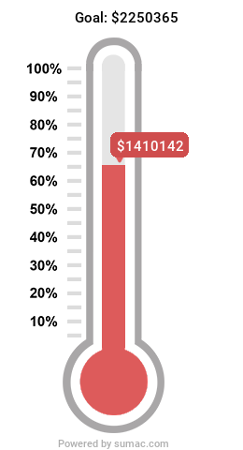

God is GOOD and FAITHFUL!
The goal is $2,250,365.00. We have $531,190 of pledged
money that will come in yet. And $309,033 still needs to be fully
funded.

The staff and students are enjoying the new facility so much!

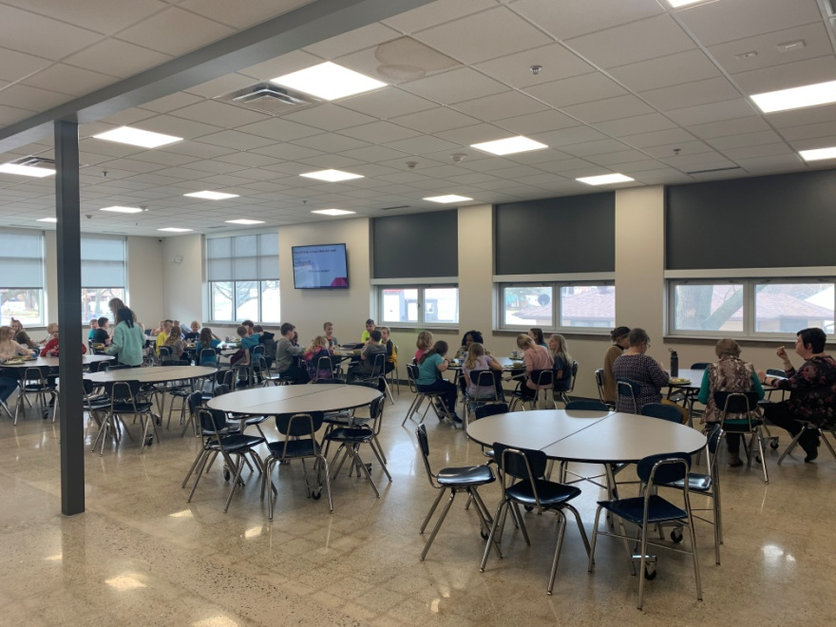
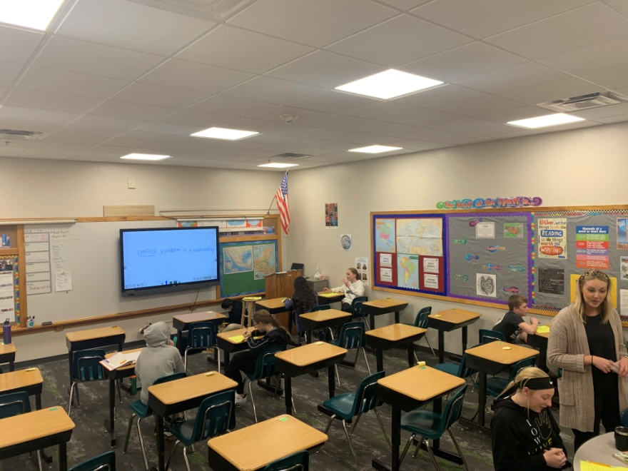

Mrs. Roose's 6th garde classroom. The carpet makes the whole room feel "homey". The students love that! Also, the BenQ's (big tv's) have been a huge hit!

The cafeteria has been so great! It's fun to hear all the kids talking and laughing together during their lunchbreak.

