Sheldon Christian Scout
2022
Sheldon Christian School prepares God's children for a lifetime of kingdom service by providing quality God-Centered Education.

WELCOME BACK!!!!
The staff at Sheldon Christian school were so excited to get the 2022-2023 school year under way! We have been very blessed to welcome many new families into Sheldon Christian!
Joe & Faith Bootsma and their daughter Eden (Preschool)
Devin & Elissa De Jong and their daughter Bella (Preschool)
Sierra & Carlos and their son Carlos Jr (preschool)
Jeffrey & Brooke Granstra and their son Wyatt (Preschool)
Brian & Kristin Hengeveld and their daughter Zoey (Preschool)
Brandon & Janna Kats and their daughter Evelyn (Preschool)
James & Kymlee Klynsma and their son Jevin (Preschool)
Ben & McKayla VanKekerix and their son Jack (Preschool)
Brent & Stephanie Zandstra and their daughter Kaley (Preschool)
Heath & Rosa Koerselman and their kids Carter (7th grade) and Aubrie (3rd grade)
David & Angela Morley and their son Raymond (8th grade)
Chad & Beth Hamill and their daughter Jane (4th grade)
Kelly & Erin Van Voorst and their daughter Raylee (4th grade)
Brent & Kendra Kamstra and their daughter Georgia (3rd grade)

NEW STAFF Member & Family: Mrs. Melissa Visser joins Sheldon Christian as the para in the Preschool Classroom. She is married to Curtis and has four children. Coen (5th grade) and Kensi (3rd grade) join us at Sheldon Christian, and her two older children Kyra and Cali attend Western.
Angela Klyn will be the new custodian this year!

The 2022-2023 School Year Theme
The 2022-2023 school year theme is The Ten Commandments. Our overall theme verse is Matthew 22:37-38, “Jesus replied: ‘Love the Lord your God with all your heart and with all your soul and with all your mind.’ This is the first and greatest commandment.” We have a desire to continually allow our students to see these commandments as God’s attempt to express what a community under God looks like and why the Ten Commandments have a dual focus – our relationship with God and with our fellow human beings. This is a plan for order within our society, a plan for morality and ethics that would guide humankind down through the centuries. They work because He knows man, and knows what we need to live a fulfilled and orderly life.

Gym Update
The gym project has been a slow and bit difficult process with the absence of available products for completion. Last year the Jog-a-thon raised over $20,000 for gym renovations. We have new wall mats with school logos on them, and they look great. We have now been able to finally purchase some needed updating to our sound system, new projection, and camera for televising events. These will hopefully be installed and ready to use in the month of September. We want to thank you for your patience, financial support, and for this overall enhancement project. It will be exciting to see the new look and hear the new sound!

School Hours
The school hours for Sheldon Christian School are 8:20 A.M -3:10 P.M. for class and instruction time each day, except Wednesdays. EVERY Wednesday this year will be a 2:10P.M. dismissal. There will always be busing on Wednesday afternoons as well.
We would like to avoid early arrivals (before 8 A.M.) as much as possible. Entrances will be opened at 8 A.M for students to enter the building. During colder months or if conditions warrant, lobby area will be open for students to wait.

Update from the SCS Building Project Finance Team
We praise God for a great start to our school year, a beautiful, safe facility, and all of the wonderful students and staff within its walls. We thank the society for your tremendous support of this project, which has greatly enhanced our school's appearance, learning spaces, and safety, allowing our children the opportunity to thrive as we provide God-centered education for life.
At a cost of over $2.2 million, we also thank God that we have nearly paid off the entire amount of the project which started a short four years ago. Our current debt is $160,000; approximately $60,000 of that is outstanding pledges and the other $100,000 is donations still needed.
Now we come to you again, asking for your help to make Sheldon Christian School debt-free by 2023. Please prayerfully consider fulfilling your outstanding pledge by the end of this calendar year or donating toward the remainder we have left to pay off on the building.

Dress Code
A reminder to parents and students to keep in mind the dress code.
• All clothes should be modest and appropriate for a Christian witness.
• Suggestive words or the advertisement of alcoholic beverages, smoking, drugs, or
anti-Christian groups on clothing are not appropriate.
• Shorts may be worn during the months of Aug., Sept., Oct., April and May. Shorts, skirts, and dresses must be finger-tip length or longer.
• All student shirts must have sleeves. The student’s midriff should not be exposed and
the shirt should not be too tight.
• Footwear is required; only athletic shoes, no sandals or flip-flops.
• Shoes that leave marks on the floors should not be worn.
• Tattoos & body piercings (except earrings for girls) or other things that call undue attention to a student will not be allowed.
• Wear appropriate clothing for winter weather such as coats, hats, gloves, and boots.
• Parents will be contacted if the child’s clothing is inappropriate.

Office Hours
Our office hours for the Administrative Assistant will be from 7:45-3:45 P.M on Monday through Friday. Please use these times to call leave your name, number, and a brief message, and we will get back to you.

Asbestos Compliance Information

In compliance with regulations of the Environmental Protection Agency (EPA), parents, teachers, and all employees are hereby notified that Sheldon Christian School has a management plan for asbestos available in the school office, should anyone desire to see it. Areas that contain asbestos are given the required periodic surveillance.

Athletic Physicals
Students in any Junior High athletic event should have a physical by their family doctor before the sporting event begins in the fall. Many places offer physicals throughout the early part of August at a lower or discounted rate. Please take advantage of these and turn in your physical forms (before the first day of school.) Athletic Physical Forms are available on the homepage of the school website or in the packet of forms available on registration night.

Parent/Student Handbook
The Parent/Student Handbooks are available online at Sheldon Christian School’s website. Please read through the materials for your own information. If anyone needs a hard copy to keep on hand, we have it available at the office.

Thank You
Over the past six months Sheldon Christian School has been abundantly blessed by memorial and estate gifts of various size. These gifts are designated for debt reduction, tuition help, general operating expenses, the school’s Foundation Fund, or just simply to use at the school’s discretion. These are selfless acts of kindness from individuals/families who have had loved ones pass on. Although they won’t receive a verbal thank you, their commitment to Christian education and the love for our school, are not unnoticed. SCS thanks these individuals/families and appreciates the opportunity to use these gifts to prepare God’s children for a lifetime of Kingdom service.

Enjoy these pictures from the first few days of school!
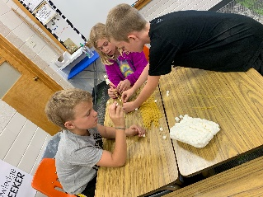
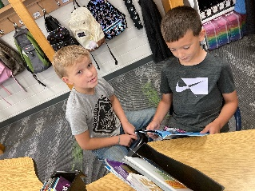
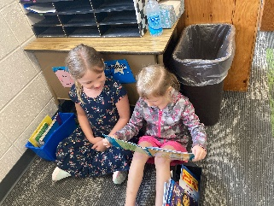
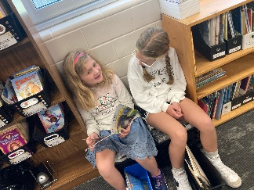

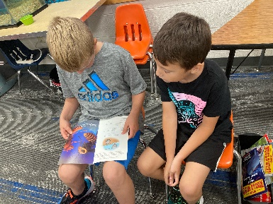
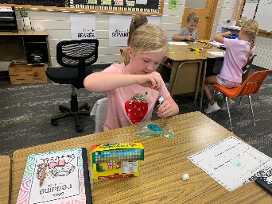
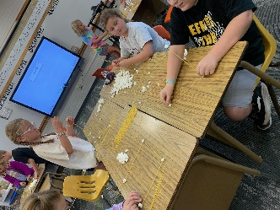
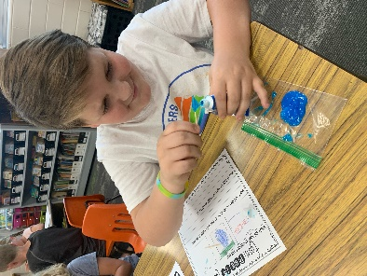

Board Meeting Briefs - August 10, 2022
Present: Jack Schreurs, Marlin Schoonhoven, Evan De Hoogh, Kyle Heynen, Katie Wieringa, Brett Vander Veen, Cleiton Zanela, Meghan Granstra. Lennis Harberts-late with notice
- Opening Devotions by Kyle Heynen
- Approve agenda- MMSC
- Approve 7-13-22 minutes – MMSC
- New Business
  - Election of officers - MMSC
    - Jack Schreurs – President
    - Kyle Heynen – V.P.
    - Scott Schmidt– Secretary
    - Katie Wieringa– Treasurer
    - Evan De Hoogh – Finance/Foundation
    - Meghan Granstra -- Education/Promotion
    - Lennis Harberts/Cleiton Zanela/Brett Vander Veen– Buildings and Grounds
  - Board orientation and Self Assessment read and discussed chapter 1 of the book, “Guiding Schools to Flourish.” We also looked at a CACE survey for Task and Expectations of Board & Administration
- Reports
  - Principal: eight new students in K-8 classes (15 total preschoolers) and 112 students total in Pre-8, Board/Staff meal was August 18, 41 new chromebooks purchased (each 4th-8th grader has their own chromebook), August 22 was Back to School Night, August 23 was first day of school
  - Building and Grounds: 1) painted railings; 2) replace a few ceiling tiles; 3) sprayed for bugs; 4) added pea rock and wood chips to play area, 5) and lined up lettering for bus
  - Executive: 1) Asked Chelsea Hulstein to be new parent on Education Committee, she has willingly accepted the three year term; 2) Family tuition was discussed; 3) Kyle Heynen and Marlin Schoonhoven met with Judy Te Grotenhuis from Agency 212 for marketing advice
  - Finance: 1) Income $11,803.19; 2) Expense $74,573.36 (ROOTS and SCRIP will be included in next months total income
  - Promotion: 1) SCS will be in Labor Day Parade; 2) Sept 13 will be Family Night at school for students and parents
- Policy Review: reviewed changes presented in the attachment for #300-332.5 Deleted #327 and #328 considered to be on “as needed” basis - MMSC
- Closing prayer by Katie Wieringa and Adjournment - MMSC
- Next meeting September 14, 2022 at 7pm

